Table of Contents
HRMS SaaS Platform — System Architecture 1
1. Vision & Scope 1
2. Guiding Architectural Principles 2
3. High-Level Architecture 3
4. Multi-Tenancy Model 3
5. Pinned Tech Stack (Implementation Decision) 4
5a. Reference Tech Stack (Later Phases / Alternatives Considered) 5
6. Core Domain Modules 6
7. AI Agent Layer 8
8. Data Architecture 9
9. API Architecture 9
10. Security & Compliance 10
11. Integration Ecosystem 10
12. Infrastructure & DevOps 11
13. SaaS Business Layer 11
14. Scalability & Reliability 12
15. Suggested Repository Structure (for an AI coding agent to scaffold) 12
16. Phased Delivery Roadmap 13
Next Steps 14

HRMS SaaS Platform — System Architecture
Purpose of this document: A complete, implementation-ready architecture for a multi-tenant Human Resource Management System (HRMS) delivered as SaaS. It is written to be handed directly to an engineering team or an AI coding agent (e.g. Claude Code) to scaffold and build the system module by module.

1. Vision & Scope
A single platform that takes an employee from hire to retire:
- Recruitment & Applicant Tracking (ATS)
- Onboarding / Offboarding
- Core HR (employee records, org structure)
- Time & Attendance
- Leave Management
- Payroll & Compensation
- Performance Management
- Benefits Administration
- Learning & Development (L&D)
- Employee Self-Service (ESS) & Manager Self-Service (MSS)
- Analytics, Reporting & Compliance
- An AI Agent Layer that sits across all modules (resume screening, HR chatbot, policy Q&A, attrition prediction, workflow automation)
Delivered multi-tenant, so any number of companies (“tenants”) run on shared infrastructure with strict data isolation, tiered pricing, and self-service signup.

2. Guiding Architectural Principles
- Modular monolith first, microservices later. Build as one deployable codebase organized into strict domain modules with clean interfaces. Extract a module into its own service only when scale/team-size actually demands it (e.g. Payroll, Notifications, AI Agent). This is dramatically easier to build correctly and cheaper to run at SaaS-startup scale than premature microservices.
- Multi-tenant by default. Every table, every query, every cache key is tenant-scoped from day one — retrofitting tenancy later is one of the most expensive SaaS mistakes.
- API-first. The frontend, mobile apps, integrations, and the AI agent all consume the same versioned API. No backend logic lives only in the UI.
- Event-driven where it matters. State changes that other modules care about (employee hired, leave approved, payroll run completed) are published as domain events on a message bus, not hard-coded cross-module calls.
- Compliance and audit are first-class, not bolted on. Every record change is audit-logged; PII is encrypted; regional data residency is a config, not a rewrite.
- AI is a layer, not a feature. The AI agent has its own service boundary, its own permission model, and reads/writes through the same APIs as a human user — it does not get backdoor DB access.

3. High-Level Architecture
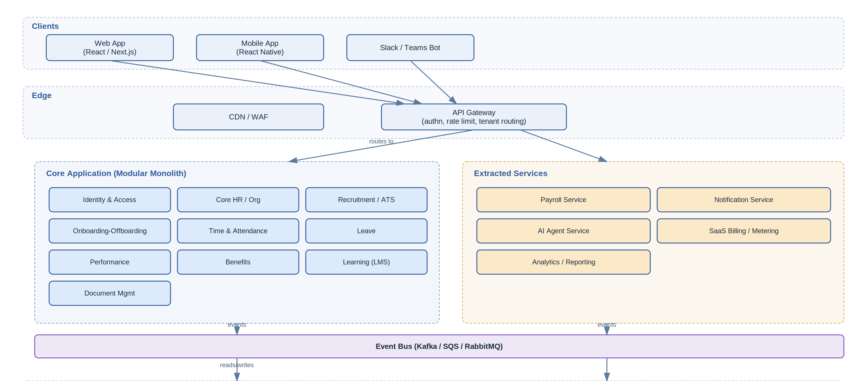
High-level system architecture
Why this shape: the gateway is the single entry point (auth, rate limiting, tenant resolution). The core modules share a database and deployment unit to start, but are coded as if they were services (own schema namespace, own internal API, no reaching into another module’s tables). Payroll, Notifications, the AI Agent, Billing and Reporting are pulled out early because they have different scaling/security/compliance profiles (payroll = financial compliance, AI agent = different runtime/cost model, reporting = read-heavy/OLAP).

4. Multi-Tenancy Model
Aspect | Approach | Notes
Isolation model | Shared database, shared schema, tenant_id on every table (v1) | Cheapest to run, fastest to build. Enforce via Postgres Row-Level Security (RLS) policies, not just app-layer WHERE tenant_id = ? — belt and suspenders.
Upgrade path | Schema-per-tenant or DB-per-tenant for enterprise/regulated customers | Offer as a paid “dedicated” tier once you have customers who need it (data residency, extreme compliance, or noisy-neighbor concerns).
Tenant resolution | Subdomain (acme.yourhrms.com) or custom domain, resolved at the API Gateway, injected into every downstream request as a signed context (JWT claim tenant_id) | Never trust a tenant_id passed in a request body.
Cross-tenant admin | Separate internal “Platform Admin” app/service with its own auth, used only by your ops team | Never share auth realm with tenant users.
Background jobs | Every job payload carries tenant_id; workers set the Postgres session variable used by RLS before executing | Prevents a whole class of “job ran for wrong tenant” bugs.
Row-Level Security pattern (Postgres):
ALTER TABLE employees ENABLE ROW LEVEL SECURITY;
CREATE POLICY tenant_isolation ON employees
USING (tenant_id = current_setting('app.current_tenant')::uuid);
Every DB connection, at checkout from the pool, runs SET app.current_tenant = '<id>' derived from the authenticated request context.

5. Pinned Tech Stack (Implementation Decision)
To avoid an AI coding agent (or a team) making inconsistent choices module-to-module, these are final decisions for Phase 0/1, not options:
Layer | Decision
Language/Backend framework | TypeScript + NestJS (chosen over Java/Spring for faster iteration at this stage; revisit only for Payroll if a compliance vendor forces a different runtime)
Frontend | Next.js (React) + TypeScript + TanStack Query + Tailwind CSS
Primary database | PostgreSQL 16, single instance for Phase 0/1, RLS enabled from the first migration
ORM/Migrations | Prisma (schema-as-code, migration history, generates TypeScript types)
Cache/Queue | Redis + BullMQ for background jobs
Auth | Custom OIDC-compatible auth in Phase 0/1 (email/password + JWT), with the module boundary built so Auth0/Keycloak SSO can be swapped in for Phase 5 without touching other modules
API style | REST, OpenAPI-first (spec is written before the endpoint, not generated from it after)
Infra (Phase 0/1) | Single environment: Docker Compose locally, one small Kubernetes cluster (or even a single ECS/Fargate service) in staging+prod — do not build the full multi-cluster Terraform setup yet
Object storage | S3-compatible bucket, one per environment, prefixed by tenant_id/
An agent should treat this table as fixed. Section 4 (tenant model) and section 8 (data model) below assume Postgres + Prisma + RLS specifically.

Phase 0 Non-Goals (explicitly out of scope — do not build yet)
To keep an AI agent from wandering into premature scope, Phase 0/1 work should not touch: - Payroll Service (any country) — stub the module boundary and the payroll.run_completed event contract only - AI Agent Service — no chatbot, no resume parsing yet; just leave the event bus emitting the events it will later consume - Billing/metering service — hardcode a single “trial” plan, no Stripe integration yet - SSO/SAML — email/password auth only - Multi-region / data residency — single region deployment - Microservice extraction — everything Phase 0/1 lives in the core modular monolith described in section 15 - Reporting/data warehouse — Phase 1 reporting reads directly from Postgres read replica if needed, no ETL pipeline yet

5a. Reference Tech Stack (Later Phases / Alternatives Considered)
Layer | Choice | Rationale
Frontend (Web) | React + Next.js, TypeScript, TanStack Query, Tailwind | SSR for marketing/onboarding pages, SPA for the app itself
Mobile | React Native | Shared logic with web team, single codebase for iOS/Android
API Gateway | Kong / AWS API Gateway / Node.js custom gateway | Auth, rate limiting, request routing, tenant resolution
Backend | Node.js + TypeScript (NestJS) or Java/Spring Boot for payroll/compliance-heavy modules | NestJS gives strict module boundaries out of the box, mirroring the architecture
Primary DB | PostgreSQL 16 | JSONB for flexible custom fields, RLS for tenancy, mature ecosystem
Cache/Queue | Redis | Sessions, rate limiting, short-lived job queues (BullMQ)
Event Bus | Kafka (scale) or Amazon SQS/SNS (simpler start) | Domain events between modules/services
Search | OpenSearch/Elasticsearch | Resume search, employee directory search, log search
Object Storage | S3-compatible | Resumes, contracts, payslips, ID documents
Data Warehouse | Snowflake / BigQuery / Redshift | For the Analytics module and BI dashboards, decoupled from OLTP load
AI/LLM | Anthropic Claude API (Claude Sonnet/Haiku tiers) | Resume parsing, HR chatbot, policy Q&A, summarization
Infra | Kubernetes (EKS/GKE/AKS) + Terraform | Cloud-agnostic, standard SaaS deployment pattern
CI/CD | GitHub Actions + ArgoCD | Standard GitOps flow
Observability | OpenTelemetry + Grafana/Prometheus + Sentry | Tracing across module boundaries is critical for a modular monolith
Auth | Auth0 / Keycloak / custom (OAuth2 + OIDC) | Must support SSO (SAML/OIDC) per tenant for enterprise customers

6. Core Domain Modules

6.1 Identity & Access Management (IAM)
- Users, roles, permissions (RBAC + attribute-based overrides, e.g. “manager can see only their direct reports’ salary”).
- Per-tenant SSO (SAML 2.0, OIDC) — this is a top-3 enterprise sales blocker if missing.
- MFA, session management, device tracking.
- Impersonation mode for support (fully audit-logged, tenant-consent gated).

6.2 Core HR / Organization
- Employee master record (personal info, employment history, compensation history — versioned, not overwritten).
- Org chart / reporting lines, departments, cost centers, locations, job families/grades.
- Custom fields per tenant (JSONB-backed, schema defined per tenant in a field_definitions table).
- Document vault per employee (contracts, IDs) with expiry tracking (visa, certifications).

6.3 Recruitment / ATS
- Job requisition → approval workflow → job posting (internal careers page + job board syndication).
- Candidate pipeline (stages, kanban), interview scheduling, scorecards.
- Resume parsing (AI Agent Layer) → structured candidate profile.
- Offer letter generation and e-signature integration.

6.4 Onboarding / Offboarding
- Templated, role-based checklists (IT provisioning, paperwork, training assignment).
- Triggered automatically by a “candidate → employee” domain event.
- Offboarding mirrors onboarding: asset return, access revocation event published to IAM, exit interview, final settlement trigger to Payroll.

6.5 Time & Attendance
- Clock-in/out (web, mobile with geofencing, biometric device integration via webhook/API).
- Shift scheduling, overtime rules engine (configurable per tenant/country).
- Feeds Payroll and Leave modules via events.

6.6 Leave Management
- Configurable leave types/policies per country/tenant (accrual rules, carry-forward, encashment).
- Approval workflow engine (reusable — also used by expense claims, ATS approvals, etc.).
- Calendar integration (Google/Outlook) for team visibility.

6.7 Payroll & Compensation (extracted service)
- Country-specific payroll engines (tax, statutory deductions) — this is the module most worth isolating early, both for compliance-blast-radius reasons and because you may license/partner with a payroll compliance vendor (e.g. Deel, Rippling-style partners, or local providers) rather than building every country’s tax logic yourself.
- Salary structures, bonuses, deductions, reimbursements.
- Payslip generation (PDF), bank file generation for disbursement.
- Immutable payroll run records (financial audit requirement — never update in place, always version).

6.8 Performance Management
- Goal setting (OKR/KPI), continuous feedback, 360° reviews, review cycles.
- Calibration workflows for managers/HRBPs.

6.9 Benefits Administration
- Benefit plans (health, retirement, etc.), enrollment windows, life-event changes.
- Carrier integration (EDI 834 or partner APIs) for US market; localized equivalents elsewhere.

6.10 Learning & Development
- Course catalog, assignment (manual or policy-triggered, e.g. compliance training on hire), completion tracking, certifications with expiry.

6.11 Employee & Manager Self-Service (ESS/MSS)
- Not a separate backend module — a frontend surface composed from the above modules’ APIs, scoped by role.

6.12 Analytics & Reporting
- Pre-built reports (headcount, attrition, DEI, comp ratio) + custom report builder.
- Reads from the data warehouse (via CDC/ETL from Postgres), never the OLTP DB directly, to avoid reporting queries degrading transactional performance.

6.13 Compliance & Audit
- Immutable audit log (who changed what, when, from where) — implemented as an event-sourced append-only table, tenant-scoped, exportable for SOC 2 / ISO 27001 evidence.
- Data retention policies, right-to-erasure workflows (GDPR), consent tracking.

7. AI Agent Layer
This is the layer the user specifically wants exposed — designed as a peer consumer of the platform API, not a privileged internal component.
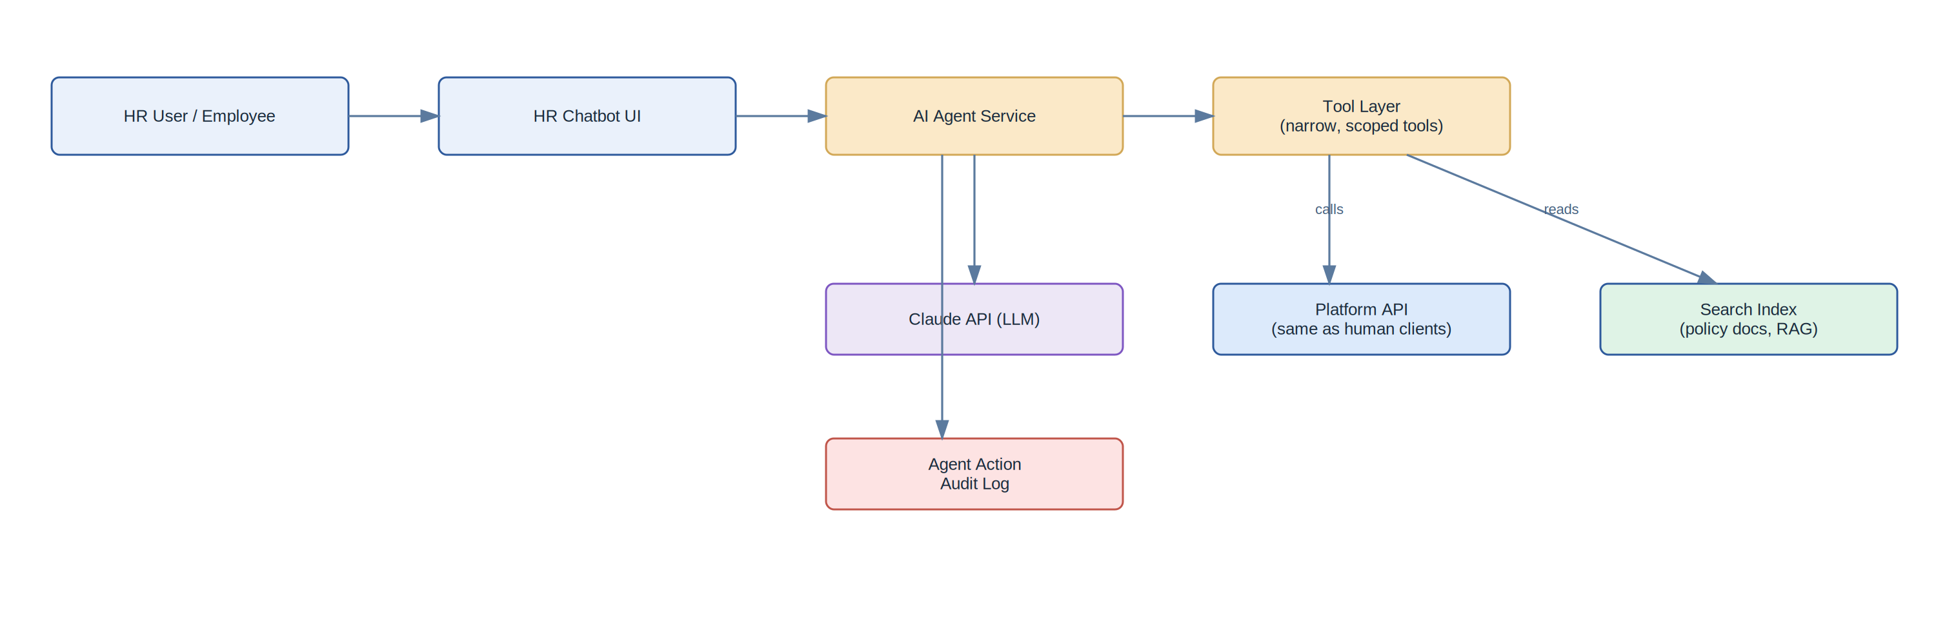
AI Agent Layer architecture
Design rules for the AI Agent Service:
- No direct DB access. The agent calls the same authenticated REST/GraphQL API every other client uses, under a service-account identity scoped by the requesting user’s actual permissions (never elevated).
- Tool-use pattern. Expose discrete, narrow tools to the LLM: get_leave_balance, submit_leave_request, search_policy_docs, get_employee_org_chart, create_ats_candidate_note. Never a generic “run this SQL” or “call this endpoint” tool.
- Human-in-the-loop for anything mutating pay, employment status, or legal documents. The agent can draft an offer letter or propose a payroll correction; a human approves before it’s committed. Read-only and low-stakes actions (checking leave balance, answering a policy question, scheduling an interview slot) can be fully autonomous.
- Every agent action is logged to the same audit trail as human actions, tagged with the acting user and the agent session, and reviewable by that tenant’s admins.
- RAG for policy Q&A. Tenant HR policy documents are chunked and embedded into the search index at upload time; the chatbot retrieves relevant chunks and answers with citations, scoped strictly to that tenant’s documents.
Concrete AI-agent use cases to build, roughly in order of ROI:
- Resume parsing & structured candidate extraction (ATS)
- HR policy chatbot (RAG over tenant’s own handbook/policies)
- Natural-language leave/attendance requests (“I’ll be out Thursday and Friday”)
- Interview scheduling assistant
- Attrition risk scoring (batch job, not chat — flags at-risk employees for HRBPs)
- Payroll anomaly detection (flags outlier pay runs for human review, never auto-corrects)
- Onboarding assistant answering new-hire FAQs

8. Data Architecture

8.1 Core entity relationships (simplified)
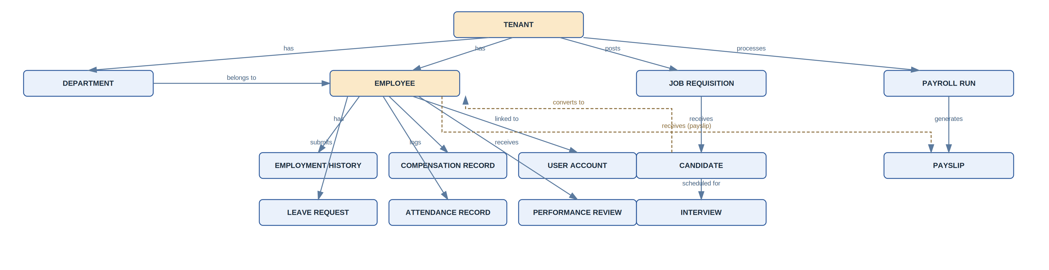
Core entity relationships

8.2 Key data-modeling rules
- Never hard-delete employee/payroll/audit records — soft delete (deleted_at) or status flags; financial and legal retention requirements demand history.
- Compensation and employment status are versioned (effective-dated rows), not overwritten — you need to answer “what was this person’s salary on March 1st” for compliance and payroll reconciliation.
- Every table has: id (uuid), tenant_id, created_at, updated_at, created_by, updated_by.
- PII fields (national ID, bank account, DOB) are encrypted at the column level (application-layer encryption, e.g. via pgcrypto or KMS-backed envelope encryption) in addition to disk encryption.

9. API Architecture
- REST, versioned (/api/v1/...), OpenAPI spec as the source of truth (generate SDKs/docs from it).
- GraphQL gateway optional layer on top for the frontend, if the UI needs flexible querying across modules (e.g. an org-chart view pulling from Core HR + Performance + Attendance in one call) — avoids over-fetching/N+1 REST calls from the client.
- Webhooks outbound for tenant integrations (e.g. “employee.hired”, “leave.approved”, “payroll.completed”) so customers can wire the HRMS into Slack, their accounting system, etc.
- Idempotency keys required on all mutating endpoints (critical for payroll and any agent-triggered actions — retries must not double-submit).
- Rate limiting per tenant and per API key at the gateway.
Example domain events published to the bus:
employee.hired
employee.terminated
leave.requested / leave.approved / leave.rejected
attendance.clocked_in / attendance.clocked_out
payroll.run_started / payroll.run_completed
candidate.stage_changed
performance_review.completed
agent.action_taken

10. Security & Compliance
Concern | Approach
Authentication | OAuth2/OIDC, per-tenant SSO, MFA enforced for admin roles
Authorization | RBAC with fine-grained permission scopes (payroll:read, payroll:approve, employee:read:direct_reports_only)
Encryption | TLS 1.2+ in transit; AES-256 at rest; column-level encryption for PII; KMS-managed keys, rotated
Audit | Append-only audit log, tenant-scoped, exportable
Data residency | Region-pinned deployments (EU tenant data stays in EU) — configurable per tenant from day one, even if you only actually deploy one region initially
Compliance targets | SOC 2 Type II, ISO 27001, GDPR, and local labor law compliance per country you support — this last one is a product/legal workstream as much as an engineering one
Secrets | Centralized secrets manager (AWS Secrets Manager/Vault), never in env files in source control
Pen testing | Scheduled third-party penetration tests before any enterprise sale — expect customers to ask for the report

11. Integration Ecosystem
- SSO/Identity: Okta, Azure AD, Google Workspace
- Payroll/Tax compliance partners: country-specific providers where you don’t build in-house
- Accounting: QuickBooks, Xero, NetSuite (GL export)
- Communication: Slack, Microsoft Teams (bot for the AI agent, leave requests, approvals)
- Calendar: Google Calendar, Outlook (leave, interviews)
- Job boards: LinkedIn, Indeed (job posting syndication)
- Background check / e-signature: Checkr-style providers, DocuSign/HelloSign
- Benefits carriers: EDI 834 feeds or carrier partner APIs
All integrations go through a dedicated Integration Hub module so credentials, retry logic, and mapping config live in one place rather than scattered across feature modules.

12. Infrastructure & DevOps
- Kubernetes (EKS/GKE/AKS), one cluster per environment (dev/staging/prod), namespaced per major service.
- Terraform for all infra as code — no manual console changes.
- CI/CD: GitHub Actions builds & tests → ArgoCD deploys via GitOps. Blue/green or canary deploys for the core app given it’s shared across all tenants.
- Database migrations via a tool like Prisma Migrate/Flyway, run automatically in the deploy pipeline, always backward-compatible with the previous release (expand/contract pattern) so rolling deploys never break.
- Observability: distributed tracing (OpenTelemetry) is non-negotiable in a modular monolith — you need to see a request’s path across module boundaries. Centralized logging (per-tenant filterable), metrics dashboards, and error tracking (Sentry).
- Backups: automated daily Postgres snapshots + point-in-time recovery; tested restore drills quarterly.
- DR: documented RTO/RPO targets; at minimum multi-AZ, ideally multi-region for the enterprise tier.

13. SaaS Business Layer
Component | Notes
Tenant provisioning | Self-service signup → automated tenant creation (DB row + default config + seed data) in seconds, not a manual ops task
Plans & pricing | Tiered by employee count + feature gates (e.g. “Performance Management” and “AI Agent” as add-ons on top of a Core HR base)
Metering | Usage events (active employees, AI agent calls, storage) recorded to a billing service; reconciled monthly
Billing | Stripe Billing (subscriptions, usage-based line items, invoicing, dunning)
Feature flags | Per-tenant, per-plan flags (LaunchDarkly or homegrown) so upsell/entitlement changes don’t require a deploy
Trial/freemium | Time-boxed or employee-count-boxed free tier, converted via in-app upgrade prompts
Admin/ops console | Internal tool for support to view tenant health, impersonate (with consent+audit), manage entitlements

14. Scalability & Reliability
- Read replicas for Postgres once reporting/analytics load grows, offloading heavy queries away from OLTP.
- Redis caching for hot, low-change data (org chart, permission sets, leave balances) with tenant-scoped cache keys and short TTLs.
- Async everything that can be: payroll runs, report generation, bulk imports, notification sending — all queued jobs, not synchronous request-path work.
- Horizontal pod autoscaling on the core app and the AI Agent Service independently (LLM calls have very different latency/cost profiles than CRUD requests).
- Circuit breakers around every third-party integration (payroll partners, e-signature, job boards) so one vendor outage doesn’t cascade.
- Multi-tenant noisy-neighbor protection: per-tenant rate limits and query timeouts so one large tenant’s bulk import can’t degrade the platform for everyone else.

15. Suggested Repository Structure (for an AI coding agent to scaffold)
hrms-platform/
├── apps/
│ ├── web/ # Next.js frontend
│ ├── mobile/ # React Native
│ └── admin-console/ # Internal platform admin app
├── services/
│ ├── api-gateway/
│ ├── core/ # modular monolith: auth, core-hr, ats, onboarding,
│ │ ├── src/modules/ # attendance, leave, performance, benefits, lms, docs
│ │ │ ├── auth/
│ │ │ ├── core-hr/
│ │ │ ├── ats/
│ │ │ ├── onboarding/
│ │ │ ├── attendance/
│ │ │ ├── leave/
│ │ │ ├── performance/
│ │ │ ├── benefits/
│ │ │ ├── lms/
│ │ │ └── documents/
│ │ └── ...
│ ├── payroll-service/
│ ├── notification-service/
│ ├── ai-agent-service/
│ │ ├── tools/ # narrow, permission-scoped tool definitions
│ │ ├── rag/ # policy doc ingestion + retrieval
│ │ └── audit/
│ ├── billing-service/
│ └── reporting-service/
├── libs/
│ ├── shared-types/ # OpenAPI-generated types
│ ├── event-schemas/ # domain event contracts
│ └── rbac/ # shared permission model
├── infra/
│ ├── terraform/
│ └── k8s/
└── docs/
├── api/ # OpenAPI specs
└── architecture/ # this document + ADRs

16. Phased Delivery Roadmap
Phase | Scope | Goal
0 — Foundation | Multi-tenancy, auth/IAM, core HR employee records, RLS, CI/CD, basic admin console | Prove the tenancy + security model before building features on top
1 — MVP | Core HR, Leave, Attendance, ESS/MSS, basic reporting | Sellable product for a single-country SMB customer
2 — Grow | ATS/Recruitment, Onboarding/Offboarding, Notifications, Billing/metering, self-service signup | Turn it into an actual SaaS funnel
3 — AI Layer | AI Agent Service, resume parsing, HR chatbot with RAG, audit trail for agent actions | Differentiator layer
4 — Scale | Payroll (start with 1-2 countries), Performance Management, Benefits, Integration Hub | Expand ACV per customer
5 — Enterprise | SSO/SAML, dedicated-tenant tier, data residency options, SOC 2 Type II, advanced analytics/warehouse | Unlock enterprise deals

Next Steps
This document is meant to be a living reference. Natural next steps from here: 1. Write ADRs (Architecture Decision Records) for the handful of choices most likely to be contested later (monolith-vs-microservices, RLS-vs-schema-per-tenant, build-vs-buy payroll). 2. Generate the OpenAPI spec for Phase 0/1 endpoints. 3. Scaffold the actual repo structure and Phase 0 code (auth + core HR + tenancy) — an AI coding agent can take section 15 + section 8’s schema directly as its starting brief. 4. Design the Postgres schema DDL in full for Phase 0/1 modules.
Happy to go deeper on any single module (e.g. full DB schema for Core HR, or the OpenAPI spec for the Leave module, or the AI Agent’s tool definitions) — just say which one.

